DESIGN PATTERNS IN SYSTEM DESIGN (feat. JAVA)

Think of Design Patterns as the "Tried and Tested Recipes" of the software world.
- Imagine you are a master chef. You aren't the first person to make a cake. Over the last 100 years, chefs realized that if you mix flour, eggs, and sugar in a specific way, it works every time. If you try to reinvent it without a recipe, your cake might collapse.
In coding, Design Patterns are standard solutions to common problems that software developers face. They aren't "code" that you copy-paste; they are templates for how to structure your classes to solve a problem.
If you are building a full-stack app (like an E-commerce site or a Social Media app), your code will eventually become huge. Without patterns, you get "Spaghetti Code" -> where changing one small thing in the Database breaks the Login screen.
Here are three core reasons why we use them:
- Don't Reinvent the Wheel: Smart developers have already solved these problems. Using a pattern saves you time.
- A Common Language: If you tell another developer, "I used a Strategy pattern for the payments," they immediately know how your code works without looking at 500 lines of logic.
- Scalability: They make your app "pluggable." You can add a "Crypto Payment" to your "Credit Card" app in minutes if you used the right pattern.
- how these patterns fit into a real application:
Type | Real-World Use Case
Creational | You have a Database Connection. You don't want 1,000 separate connections slowing down your server; you only want one. (Singleton)
Structural | You want to add a "Premium" border around a user's profile picture without changing the original Image class. (Decorator)
Behavioral | When a user "Likes" a post, you need to notify the author, update the database, and alert the analytics team. (Observer)

- Creational (The "How to Create" patterns): How do we build objects without making a mess?
- Structural (The "How to Connect" patterns): How do we make different classes work together like Lego bricks, means we are connecting systems that weren't originally meant to talk to each other.
- Behavioral (The "How to Talk" patterns): How do objects send messages and instructions to each other?

CREATIONAL DESIGN PATTERNS
1 The Singleton Design Pattern
The Simple Analogy
Imagine a Company CEO. In a single company, you only have one CEO. If anyone in the company (the "objects" in your code) needs a high-level decision, they don't hire a new CEO; they go to the one and only office where the CEO sits.
The Problem Scenario
Imagine you are building a Full-Stack E-commerce App. You have a class called DatabaseConnector.
- Every time a user views a product, you create a new DatabaseConnector().
- Every time a user adds to cart, you create a new DatabaseConnector().
- If 1,000 users are on your site, your server is trying to open 1,000 separate connections. The database will crash because it can't handle that many open "pipes" at once.

The Solution
We make the DatabaseConnector a Singleton. No matter how many people are using the app, they all share one single connection pipe.
Eg:
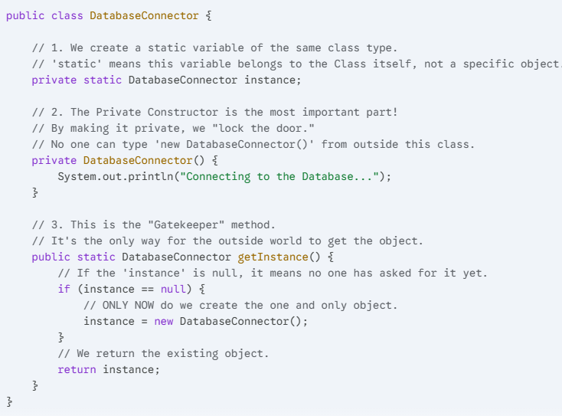

How this relates to the pattern:
- private static DatabaseConnector instance: This is the "Single Instance" storage.
- private DatabaseConnector(): This enforces the rule that you cannot create multiple copies.
- if (instance == null): This ensures "Lazy Initialization"—we don't waste memory creating the object until someone actually needs it.
Use Cases
- Application Configuration (Backend): Your app has a config.properties file (with API keys, Port numbers, etc.). You only want to load this file into memory once when the server starts. A Singleton ConfigManager ensures every part of your backend reads from the same settings.
- Redux/State Management (Frontend): In a React or Angular app, your "Global Store" (the place that holds the user's login status) acts like a Singleton. You want the Navbar and the Profile page to look at the exact same data object.
- Logging Service: Whether an error happens in the "Payment" module or the "Login" module, you want them both to write to the same error.log file. A Singleton Logger coordinates this so they don't overwrite each other.

Connection to SOLID
The Singleton pattern primarily follows the Single Responsibility Principle (SRP).
- Why? The class takes on the responsibility of managing its own lifecycle. It ensures that it is only created once and provides a central point of access, so the rest of your application doesn't have to worry about managing "how many connections are open."

2 The Factory Design Pattern
The Simple Analogy
Imagine you go to a Pizza Shop. You don’t go into the kitchen and start mixing flour, chopping pepperoni, and heating the oven yourself. You simply look at the menu and say, "I want a Veggie Pizza."
The shop has a "Factory" (the kitchen) that knows exactly how to make a Veggie Pizza, a Cheese Pizza, or a Pepperoni Pizza. You don't care how it’s made; you just care that you get a "Pizza" back.
The Problem Scenario
Imagine you are building a Full-Stack Notification System. Initially, your app only sends Emails. Your code looks like this everywhere: EmailNotification n = new EmailNotification();
Suddenly, your boss says, "We need to send SMS and Push Notifications too!" Now, you have to go to every single file in your project and write: if (type == "SMS") { ... } else if (type == "Email") { ... }
The Headache: Your code becomes messy, hard to maintain, and every time you add a new notification type (like WhatsApp), you have to change 50 files.
The Solution
You create a NotificationFactory. Your main code just says, "Hey Factory, give me a 'SMS' object." The Factory handles the "how."

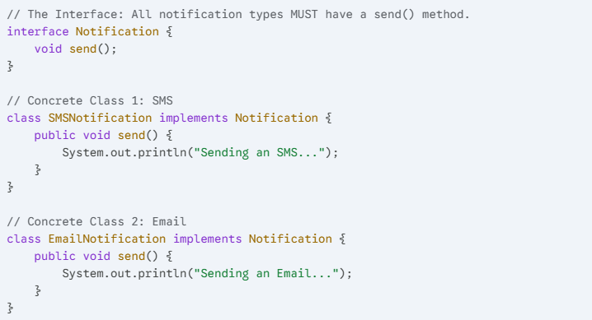

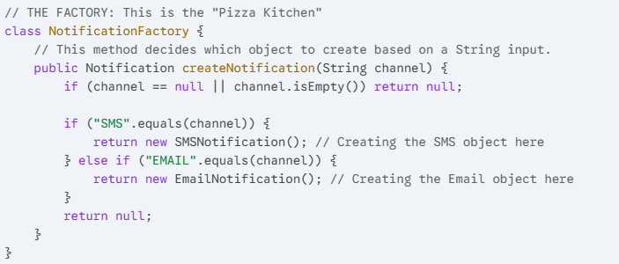
How this relates to the pattern:
- interface Notification: We rely on an abstraction, not the specific class.
- createNotification(String channel): This is the "Factory Method." It hides the logic of new SMSNotification() from the user.
- Decoupling: The user (client) never knows exactly which class they are using; they just know it’s a "Notification."
Use Cases
- Payment Gateways (Backend): Your app supports PayPal, Stripe, and Apple Pay. Instead of writing separate logic for each, you use a PaymentFactory. When the user clicks a button, the factory gives you the correct "Payment Object" to process the transaction.
- UI Component Library (Frontend): Imagine a system that generates buttons. On Windows, it creates a WindowsButton; on Mac, a MacButton. The ButtonFactory checks the user's Operating System and gives the right look without the developer writing "if/else" for every button.
- Database Drivers: Your app might need to connect to MySQL for user data but MongoDB for logs. A DatabaseFactory can provide the correct connection object based on the "type" of data you are handling.

Connection to SOLID
The Factory Method follows the Open/Closed Principle (OCP).
- Why? If you want to add a new notification type (like "WhatsApp"), you don't change your main application code. You simply create a new WhatsAppNotification class and add one line to the Factory. The rest of your app remains closed for modification but open for extension.

3 The Abstract Factory Design Pattern
The Problem Scenario: FACTORY DP IS ABSTRACTED OVER ONE MORE FACTORY DP
Imagine you are building a Full-Stack Travel App. You have two types of trips: Luxury and Budget.
- Luxury Trip: Five-star Hotel + First Class Flight.
- Budget Trip: Hostels + Economy Flight.
If your code accidentally mixes a First Class Flight with a Hostel, the customer will be very confused! Without a pattern, you have to write if/else everywhere to make sure you don't mix them up.
The Solution
You create a TripFactory.
- The LuxuryFactory only knows how to book 5-star hotels and 1st class flights.
- The BudgetFactory only knows how to book hostels and economy flights. You pick the factory once, and it handles the "matching" for you.
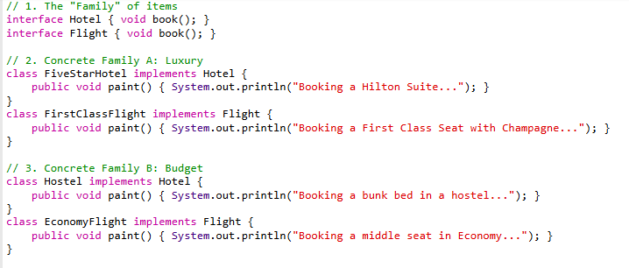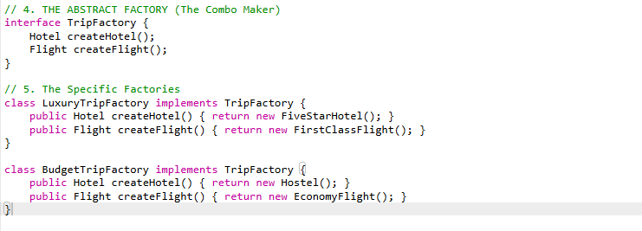

- interface TripFactory: This defines the "Menu." It says "Any trip factory must provide a Hotel and a Flight."
- LuxuryTripFactory: This is a specific "Chef." When asked for a hotel, he only knows how to return a FiveStarHotel.
- createHotel() / createFlight(): These are the individual "Factory Methods" working together as a team.
Use Cases
- E-commerce Logistics: Different regions have different "families" of providers. In the USA, a USAOrderFactory might produce a FedExShipping object and a USDaxPayment object. In India, an IndiaOrderFactory would produce BlueDartShipping and UPIMethod objects. It prevents mixing a US shipping provider with an Indian payment method.
- Database Migration Tools: If you are moving data from SQL Server to MySQL. You need a "Source Factory" (which creates SQL Readers/Connections) and a "Destination Factory" (which creates MySQL Writers/Connections).
- Gaming (Full-Stack Engine): A "Level Factory." In a Desert Level, the factory produces SandMonster and CactusObstacle. In an Ice Level, it produces SnowMonster and IceBlockade. You never want a Snow Monster appearing in the Desert!

Connection to SOLID
This pattern follows the Dependency Inversion Principle (DIP).
Why? The main logic of your Travel App doesn't depend on the Hostel class or the FiveStarHotel class. It depends on the Hotel interface. You can swap the entire "Luxury" experience for a "Standard" experience by just changing one line of code (the factory name), and the rest of the app keeps working perfectly.

In Simple terms, it is an Abstraction over Factory Method.

3 The Builder Design Pattern

The Simple Analogy: The "Subway Sandwich"
Imagine you are at a Subway. You want a sandwich.
- If the employee used a standard Constructor, they would ask you: "Do you want full-bread, Wheat, Turkey, Lettuce, Tomato, Mayo, Toasted, Olives...?" all in one breath.
- If you only wanted Bread and Turkey, you would still have to say "No" to the other 10 ingredients. It's confusing and you might mix up the order.
Instead, they use the Builder approach:
- First, pick the bread.
- Then, pick the meat.
- Then, add veggies (optional).
- Finally, "Build" the sandwich.

The Problem Scenario
Imagine you are building a Full-Stack User Profile. A user has:
- Required: Username, Email.
- Optional: Bio, ProfilePic, Age, PhoneNumber, IsPremium, Address.

If you use a normal constructor, it looks like this: User u = new User("John", "john@email.com", null, null, 0, null, true, "123 Street");

The Headache: This is called the "Telescoping Constructor Nightmare." You have no idea what that 0 or null or true stands for without looking at the source code. If you want to add just the Bio, you still have to pass values for everything else.

The Solution
You create a UserBuilder. You set only what you need, and then you call .build().
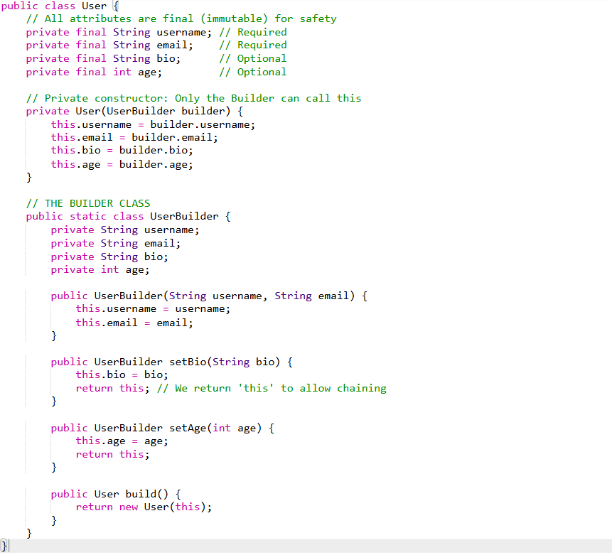
Code Breakdown:
- return this;: This is the magic. It allows Method Chaining (.setBio().setAge()), which reads like a sentence.
- private User(UserBuilder builder): The actual User object is created only at the very end.
- Flexibility: If I don't want to set the age, I simply don't call .setAge(). No more passing null or 0 manually!
Use Cases
- SQL Query Builder (Backend): Instead of writing a long string like "SELECT * FROM users WHERE age > 18 AND city = 'NY' ORDER BY name", you use a builder: query.select("*").from("users").where("age > 18").orderBy("name").build(); This prevents errors and is much easier to read.
- HTTP Request Headers: When calling an external API, you often need to set various headers (Auth tokens, Content-type, Cookies). A RequestBuilder lets you add only the headers you need for that specific call.
- UI Document Generator: If you are generating a PDF invoice. You might add a Header, then 10 LineItems, then a Footer, then a TaxCalculation. The Builder keeps track of the complex assembly process.
Connection to SOLID
The Builder Pattern follows the Single Responsibility Principle (SRP).
- Why? The User class is only responsible for holding data. The UserBuilder class is responsible for the complex logic of creating that data. By separating them, both classes stay simple and clean.

STRUCTURAL DESIGN PATTERNS
Why do we need Structural Patterns?
In a Full-Stack application, you often have to make different "worlds" talk to each other.
- Old vs. New: Your new backend needs to talk to a 10-year-old legacy database.
- Internal vs. External: Your app needs to use a 3rd-party Payment API (like Stripe) that doesn't match your code's format.
- Complex vs. Simple: Your system has 50 complex classes, but you want to give the Frontend developer a simple "One-Click" button to trigger them all.
Structural patterns solve the "It doesn't fit!" problem.
Full-Stack Use Case: The "Legacy Integration"
Imagine you are building a modern Banking App.
- The Problem: Your modern app uses JSON to read data. However, the bank's old mainframe server (from 1995) only sends data in XML.
- The Conflict: You don't want to rewrite your entire modern app to handle XML, and you can't change the bank's old server.
- The Structural Solution: You build an Adapter (a structural pattern). It sits in the middle, takes the XML, and "repackages" it into JSON. Your modern app is happy, and the old server is happy.

- The Adapter Pattern:
The Simple Analogy: The "Travel Plug"
Imagine you have a laptop from the USA (with flat pins) but you are in India (where outlets have round pins).
- You can't change your laptop's plug.
- You can't change the wall outlet.
- The Solution: You buy an Adapter. It has flat holes on one side (for your laptop) and round pins on the other (for the wall).

The Problem Scenario
You are building a Full-Stack Weather App.
- Your app has an interface called IWeatherTracker that expects a getTemperatureInCelsius() method.
- You decide to use a 3rd-party library called FancyTempLibrary, but it only has a method called getTempFahrenheit().
Your code is "incompatible" with the library.
The Solution
You create a WeatherAdapter class. It "wraps" the 3rd-party library and converts the Fahrenheit data into Celsius so your app can understand it.
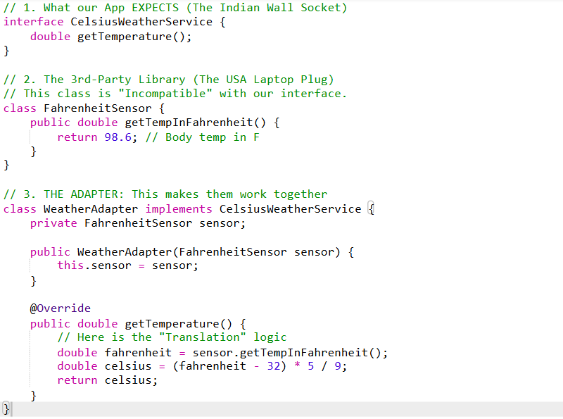
Code Breakdown:
- implements CelsiusWeatherService: The Adapter "disguises" itself as the thing the app expects.
- private FahrenheitSensor sensor: The Adapter holds a reference to the "weird" 3rd-party object.
- getTemperature(): When the app calls this, the adapter calls the 3rd-party method, converts the result, and returns the converted value.
Full-Stack Use Cases
- Third-Party Payment Gateways: Your app has a standard processPayment() method. When you add PayPal, their API might use makeTransaction(). Instead of changing your code, you create a PayPalAdapter.
- Displaying Data (Frontend): Your Chart library expects data in an Array format [1, 2, 3], but your Backend API sends data as an Object {val1: 1, val2: 2, val3: 3}. You write a small adapter function to convert the Object into an Array before passing it to the Chart.
- Logging Frameworks: You want to switch from Log4j to Slf4j. Instead of rewriting logs in 100 classes, you use an Adapter that maps your old log calls to the new library.
Connection to SOLID
The Adapter Pattern follows the Dependency Inversion Principle (DIP).
- Why? Your high-level code doesn't depend on the "weird" 3rd-party FahrenheitSensor. It depends on the CelsiusWeatherService interface. The Adapter ensures that the high-level and low-level modules remain decoupled.

- The Decorator Pattern (Like an Onion with layers)

The Simple Analogy: The "Build-a-Pizza"
Imagine you are standing at a pizza counter.
- The Core (The Base): You start with a Plain Crust. This is a functional pizza, but it's very basic.
- The First Wrap: you put it inside a "Cheese Box." Now, when someone asks "What is this?", the box says: "It's a Crust... PLUS Cheese."
- The Second Wrap: You take that whole box and put it inside a "Tomato Box." Now, the outer box says: "It's whatever was in that other box... PLUS Tomato."
The result: You haven't changed the crust. You haven't changed the cheese. You have just layered them.
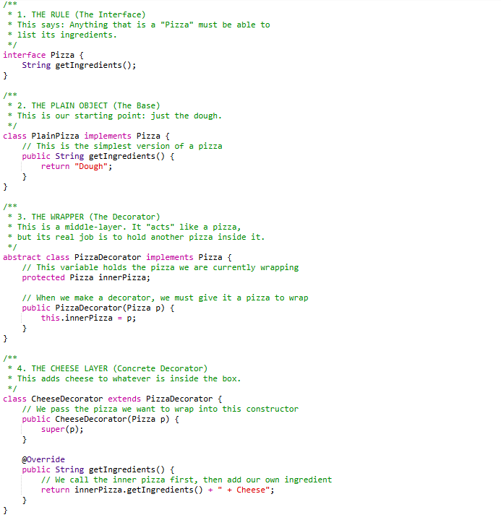
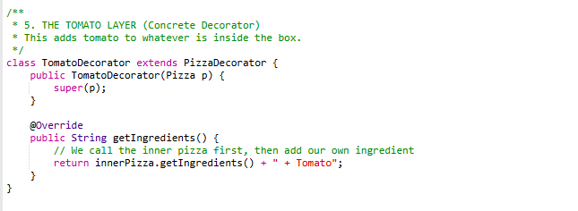

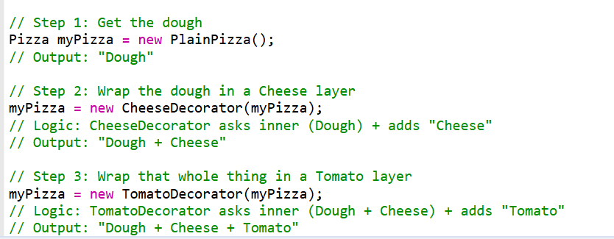

Use Case:
- User Permissions (Security): Imagine a UserContent object. You wrap it with an AdminDecorator. If the user is an Admin, the decorator "adds" an Edit Button and a Delete Button to the content. If they are a normal user, you don't wrap it, and they only see the View option.
- File Uploading: When a user uploads a photo, you have a BasicUpload. You can wrap it in a ResizeDecorator (to make it smaller), then wrap it in a WatermarkDecorator (to add your logo on top). The base upload code stays the same!
- Notification System: You have a BasicMessage. Depending on user settings, you wrap it with an EmailDecorator, then an SMSDecorator. The system sends the message through every "layer" you added.
Connection to SOLID
This pattern follows the Open/Closed Principle (OCP).
- Open for Extension: You can create 100 new toppings (Chicken, Onion, Olives) by just making new classes.
- Closed for Modification: You never have to open the PlainPizza.java file and change its code to add these toppings.
In Simple terms:
The Decorator Pattern is a way to add new features to an object by "wrapping" it inside another object, like adding layers to a pizza without changing the dough. We use it so we can combine different behaviors (like Cheese + Tomato) at runtime without creating a separate class for every possible combination.

3 . The Facade Patterns
The Simple Analogy: The "One-Touch Coffee Machine"
Imagine you want a Cappuccino.
- Without a Facade: You have to manually grind the beans, boil the water, froth the milk, and mix them in the right order.
- With a Facade: You just press one button that says "Cappuccino." The button is the Facade. It hides all the messy internal steps (grinding, boiling, frothing) and gives you what you want simply.

The Problem Scenario
Imagine you are building a Full-Stack Order System. To finish a purchase, your code must:
- Check the Warehouse (Is it in stock?).
- Talk to Stripe (Is the payment okay?).
- Talk to Shipping (Generate a label).
- Send a Confirmation Email.
If you make the Frontend developer write all 4 lines of code every time, they will eventually forget one, and your app will break.

The Solution
You create an OrderFacade. It has one simple method: placeOrder(). It handles all 4 steps inside, so the rest of the app doesn't have to see the mess.
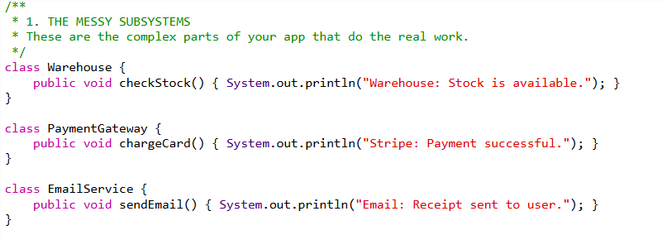

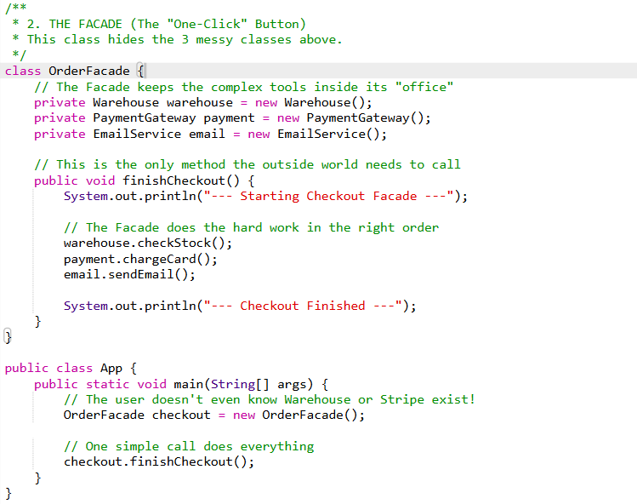
The Facade Pattern is like a "Universal Remote" that hides a complex system behind one simple button. We use it to make a messy group of classes easy to use for other developers.
Use Cases
1. The "Social Media Share" Facade
Imagine your app has a "Share This" button. To share a post, you need to talk to the Facebook API, the Twitter (X) API, and the LinkedIn API. Each one has different rules, different security keys, and different code.
- Without Facade: The Frontend developer has to write three different complex functions.
- With Facade: You create a SocialShareFacade. The developer just calls share(message). The Facade handles the "messy" work of talking to all three platforms at once.
2. The "App Startup" Facade
When a large Full-Stack app starts up, it needs to do a lot of "boring" setup:
- Connect to the Database.
- Initialize the Cache (Redis).
- Load Configuration files.
- Start the Logger.
- The Facade Solution: You create a SystemLauncher class. In your main file, you just call launcher.start(). This hides the 20-30 lines of setup code and ensures everything starts in the correct order.
3. The "Multimedia Converter" Facade
If you are building a site like YouTube or Instagram, when a user uploads a video, you need to:
- Compress the video.
- Extract a thumbnail image.
- Check for viruses.
- Upload to a cloud bucket (like AWS S3).
- The Facade Solution: Instead of the "Upload Controller" doing all that work, it talks to a VideoProcessingFacade. The controller says process(videoFile) and the Facade coordinates the compressor, the thumbnail maker, and the cloud uploader.
In Simple terms:
"A Facade is like a Receptionist. You don't go into the back office and talk to the accountant, the lawyer, and the manager separately. You just talk to the Receptionist, and they handle everything inside the building for you."
We have covered:
- Adapter: The "Travel Plug" (makes things fit).
- Decorator: The "Pizza Toppings" (adds new layers).
- Facade: The "One-Click Button" (hides complexity).

- Proxy Design Pattern
In a Full-Stack application, you often have objects that are "expensive" (they take a lot of memory or time to load) or "sensitive" (they need security). The Proxy stands in front of the real object to protect it or manage it.

Imagine you are in a big company.
- The Real Object: The Huge Industrial Printer. It is loud, uses a lot of power, and is expensive to run.
- The Proxy: The Print Queue (The Software on your computer).
- The Logic: When you click "Print," you don't talk to the physical printer directly. You talk to the Queue (Proxy).
  - The Proxy checks: "Do you have permission to print in color?" (Security).
  - The Proxy checks: "Is the printer busy?"
  - The Proxy waits until the printer is ready before it sends the job.
Lazy Loading:
In simple terms, Lazy Loading is the "Don't do it until you absolutely have to" strategy.
It is a design technique where you delay the loading or initialization of an object (especially a "heavy" one) until the very moment it is needed.

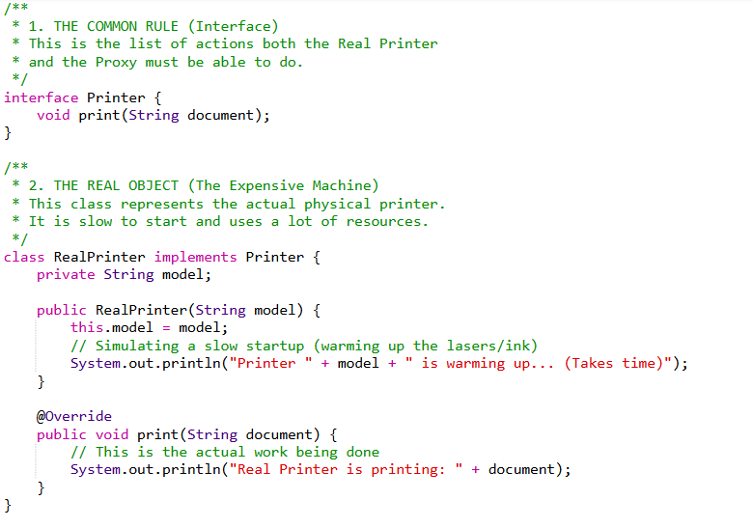

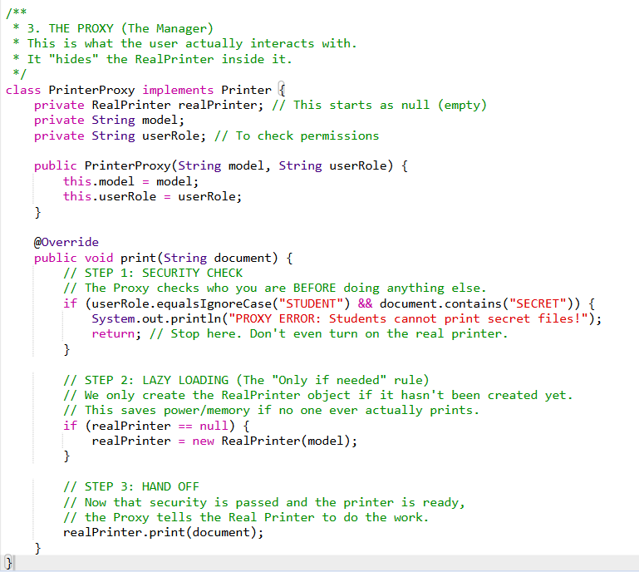
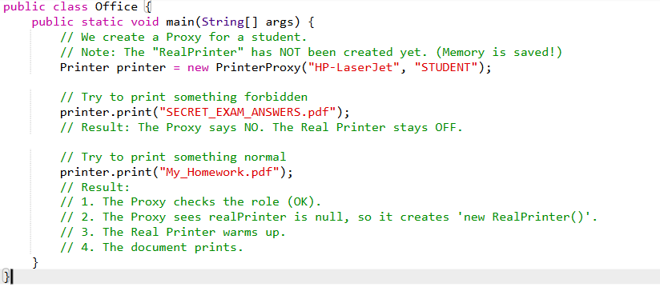
The User thinks they are talking to a Printer, but they are actually talking to a Guard (The Proxy).
- Gatekeeping: The Proxy stopped the "Secret" file from printing. The Real Printer never even knew someone tried.
- Laziness (Efficiency): If the main method never called .print(), the RealPrinter would never have been created. This is great for Full-Stack apps because you don't load heavy things until the user clicks them.
In Simple Terms:
The Proxy Pattern is like a "Secretary." You give your document to the Secretary (Proxy), and they check if you have permission and if the Boss (Real Object) is busy before they hand it over. We use it to add a layer of control (Security) and to save effort (Lazy Loading) for the main object.

Use-Case:
1. The "Virtual Proxy" (Lazy Loading)
Scenario: You are building an app like Instagram. A user’s profile has 500 high-resolution photos.
- The Problem: If you load all 500 photos the moment the page opens, the app will be very slow and use all the user's mobile data.
- The Proxy Solution: You show a tiny "Placeholder" (Proxy) for each photo. The Proxy only downloads the Real High-Res Photo when that specific photo scrolls into view.
- Benefit: The app feels instant and saves data.

2. The "Protection Proxy" (Security)
Scenario: You have a class in your Backend that can Delete a Database.
- The Problem: You don't want to accidentally call deleteDatabase() from a part of the code that hasn't checked if the user is an Admin.
- The Proxy Solution: You create a DatabaseProxy. Whenever someone calls delete(), the Proxy checks the user's "Role" or "API Key" first. If they aren't an Admin, the Proxy returns an "Unauthorized" error and never calls the real delete function.
- Benefit: You centralize your security logic in one "Guard" object.

3. The "Caching Proxy" (Speed)
Scenario: You have an API that fetches the Current Stock Price of Apple.
- The Problem: Every time a user refreshes the page, your server makes an expensive network call to the Stock Exchange. This is slow and might cost you money per API call.
- The Proxy Solution: The Proxy sits between your app and the Stock Exchange.
  - User 1 asks for the price. Proxy gets it and saves a copy (Cache).
  - User 2 asks for the price 5 seconds later. The Proxy gives the saved copy instead of making a new network call.
- Benefit: Massive speed boost and lower costs.

Behaviour Patterns
If Structural Patterns are about how objects are built, Behavioral Patterns are about how objects talk to each other.
Imagine a Football Team:
- Structural: This is the physical setup. You have 11 players, they wear jerseys, and they have specific positions (Goalkeeper, Striker).
- Behavioral: This is the gameplay. How does the Goalkeeper signal the Defender? How does the Midfielder know where to pass the ball? It’s the logic of the movement and the communication between them.
The Problem these patterns solve: "Spaghetti Communication"
In a big application, you might have 50 different classes. If every class talks to every other class directly, your code becomes a "Spiderweb." If you change one thing, 10 other things break because they were all "listening" or "waiting" in a messy way.
Behavioral Patterns give us "Traffic Rules" so that objects can exchange information without getting tangled.

  - The Observer Pattern:
The Concept: "Don't call me, I'll call you."
In this pattern, one object (the Subject) keeps a list of other objects (the Observers) who want to stay updated. When something changes in the Subject, it automatically sends a message to everyone on that list.

The Simple Analogy: The "News App"
- The Subject: The News Agency (like BBC or CNN).
- The Observers: The thousands of people who downloaded the app on their phones.
- The Behavior: The News Agency doesn't know who you are personally. It just has a list of "Device IDs." When a "Breaking News" story happens, it pushes a notification to every ID on that list at once.

The Problem without this pattern
If you didn't have this, your phone would have to ask the News Agency every 10 seconds: "Is there news yet? How about now? Now?" This is called Polling, and it kills your battery and slows down the server.

The Solution with Observer
The phone stays quiet. It only reacts when the News Agency "pushes" the update.
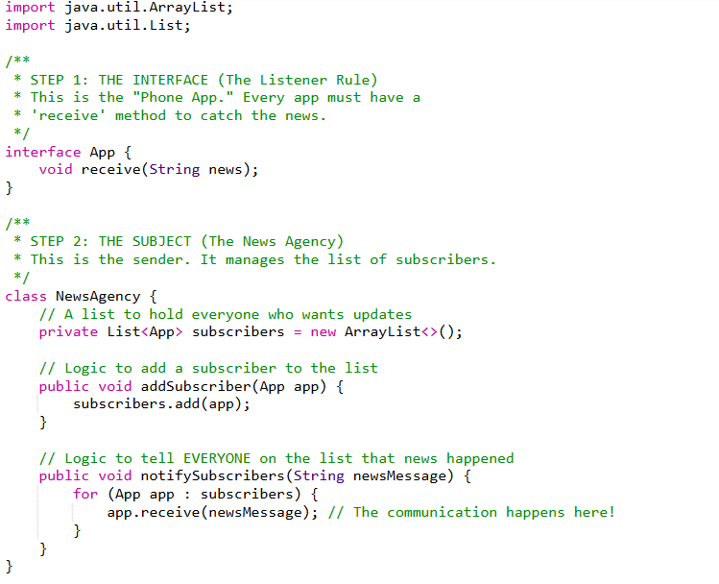
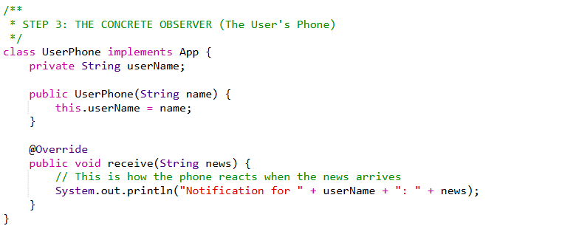
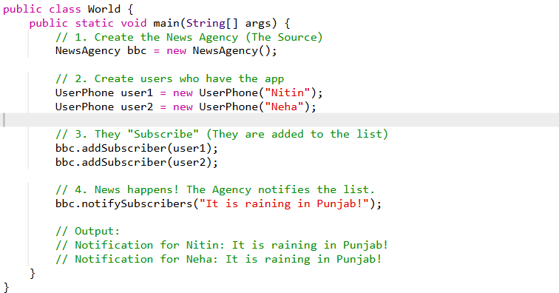
Use-cases:
- Backend: When a user buys a product, the OrderService (Subject) notifies the EmailService, SmsService, and InventoryService (Observers) to do their jobs.
- Frontend: In React or Vue, when the "State" (Subject) changes, the "UI Components" (Observers) automatically re-render themselves to show the new data.
- WebSockets: In a chat app like Discord, when one person types a message, the server "pushes" that message to everyone else in the channel.

  - The Strategy Pattern
The Concept: "Pick a tool for the job."
The Strategy Pattern allows an object to change its behavior (or its algorithm) at runtime. Instead of having one giant class that tries to do everything, you create separate classes for each "strategy" and swap them in as needed.
The Simple Analogy: The "Travel Map"
Imagine you are going from New York to London.
- There are different Strategies to get there: Flying, Sailing, or Swimming (maybe not swimming!).
- You (the traveler) don't change. Your destination doesn't change.
- Only the Way (Strategy) you move changes based on your budget or time.

The Problem without this pattern
If you were writing code for a travel app, you might have a messy function like this:
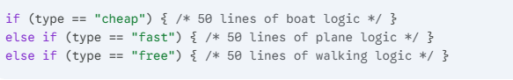
This is hard to read, hard to test, and if you want to add "Train" logic later, you have to break the whole file.
The Solution with Strategy
You create a TravelStrategy interface. Then you make separate classes: PlaneStrategy, BoatStrategy, and WalkStrategy.

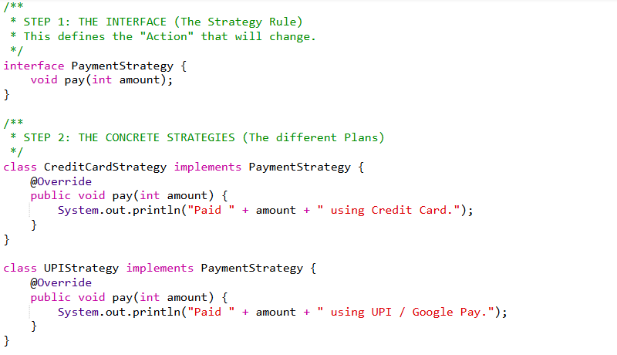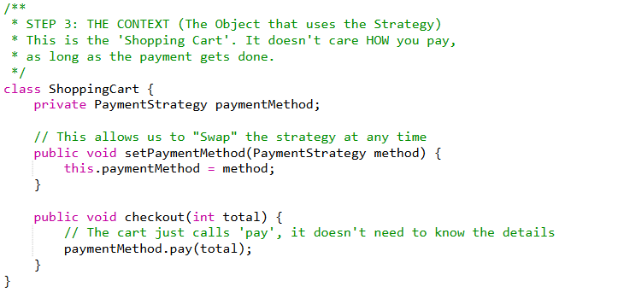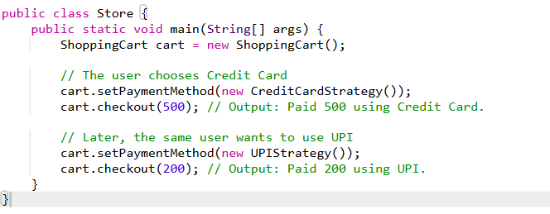
Use-Case:
- Sorting: On an e-commerce site, you can sort by "Price: Low to High," "Newest First," or "Rating." Each of these is a different Sorting Strategy.
- File Compression: An app might save a file as .zip, .rar, or .7z. The app uses a Compression Strategy to handle the different math for each format.
- Authentication: A website allows you to login with "Email/Password," "Google," or "GitHub." Each one is an Auth Strategy.
Connection to SOLID
This pattern is the king of the Open/Closed Principle.
- You can add a CryptoPaymentStrategy tomorrow by just creating one new class. You don't have to touch the ShoppingCart class at all!

